l o g i s t i c s , l l c

HG LOGISTICS HUB
HG LOGISTICS HEADQUARTERS
HG LOGISTICS HEADQUARTERS

HG LOGISTICS HUB

WHAT WE OFFER
TL COVERAGE to all 48 states plus Canada and Mexico Vans/Flatbeds/Stepdecks/RGNs/Reefers/Team Service Hazardous/Straight Trucks/Blanket Wrapped/Oversized Mutli-Pick or Mutli-Drop/Air Ride/Spealialized Equipment 24/7 Dispatch
Single point of contact TIA Certiﬁed
LTL COVERAGE to all 48 states plus Canada and Mexico

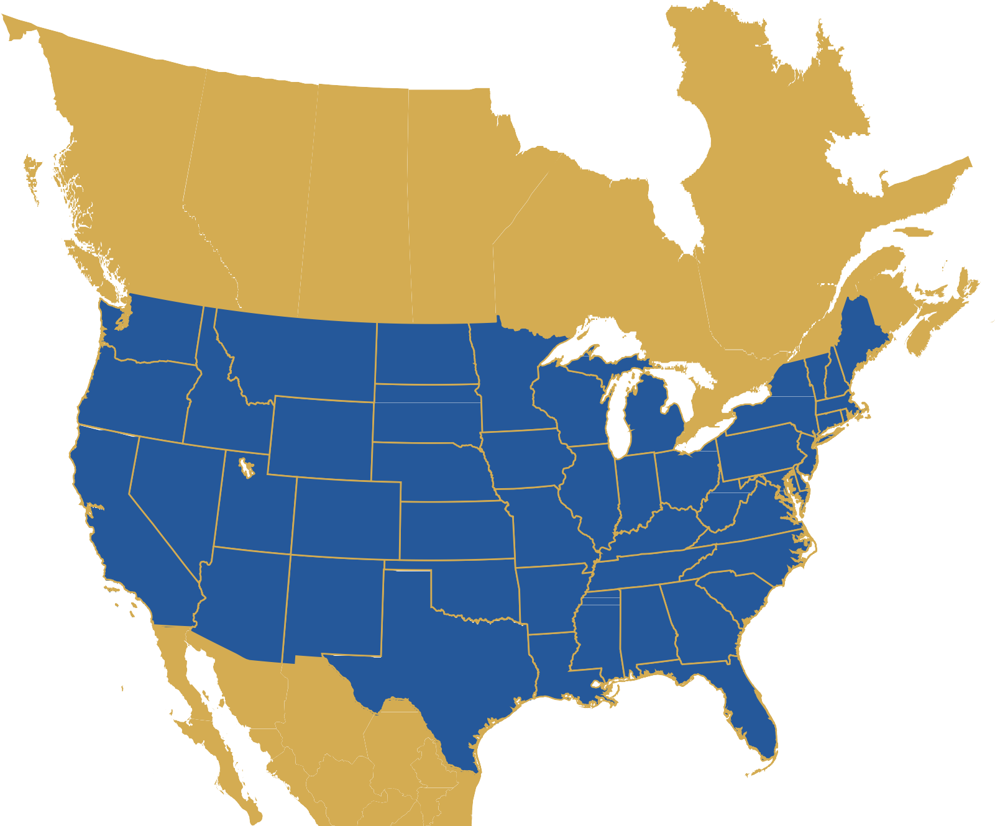FTL
LTL
Over 120 Years
Expedited and Guaranteed Services Rail to All 48 states Intermodal/International
Air


Company Information

logistics,llc

HG Logistics, LLC
Established – 2006
1085 Summer Street, Cincinnati, Ohio 45204 www.hillandgriffith.com • www.hglogisticsllc.com 513-244-3026 • 513-244-4199 (fax)
MC # 569982 US DOT # 2236963 FID #93-3737320
HAZMAT Reg. No: 101512 550 009UW
TIA Member in Good Standing since 2006 Smartway Partner
Recipient: 2-time Tropicana Central Region Carrier of the Year

Bank Reference
First Merchants Bank Baily Sons
707 Ridge Road Acct #101924386
Munster, IN 46321 219-864-1330
Insurance
Avalon Risk Management (Cargo and General Liability) Contact: Melissa Aternino 847-700-8080
ARMCentral@avalonrisk.com
$100,000 Surety Bond, Merchants Bonding Company Ohio Bureau of Worker’s Compensation
Policy No. 1538758
Sister Company Information
The Hill and Griffith Company, est. 1896 MC # 180685
Ryan Canfield, President Mike Lawry, CEO
Insurance: USI Insurance Services, LLC Contact: Joey St. John 513-964-1046
HG Logistics Management Team
Mike Rieck, Director of Sales mrieck@hglogisticsllc.com, 513-244-3022
Katrina Kilgore, Director of Operations kkilgore@hglogisticsllc.com, 513-244-4196
Nancy Sauers, Accounting Administrator nsauers@hglogisticsllc.com, 513-244-4195



MEMBER ®
Cincinnati • Indianapolis

Credit Application

logistics,llc

CREDIT APPLICATION
General Company Information:
Company Name:
Street Address:
City: |  |  |  | State: |  |  | Zip Code:
Phone: |  |  | Email Address:
Website: |  |  |  |  |  |  | Established:
Please Check the Relevant Category:
Corporation |  | Partnership |  |  | Limited Partnership |  |  | Proprietorship
Applicant’s Information:
Applicant’s Name:
Applicant’s Position:
Phone: |  |  | Email Address:
Accounting Information:
Contact Name: |  |  |  |  |  |  | Phone:
Preferred Method to Receive Invoices: Email Mail
Email Address:
Billing Address:
City: |  |  |  | State: |  |  | Zip Code:
Bank Reference:
Bank Name:
Street Address:
City: |  |  |  | State: |  |  | Zip Code:
Account Number: |  |  |  |  |  | Officer’s Name:
Phone: |  |  | Email Address:
Credit References:
Reference #1 | Name: |  |  |  |  | Company Name:
Street Address:
City: |  |  |  | State: |  |  | Zip Code:
Phone: |  |  | Email Address:
Reference #2 | Name: |  |  |  |  | Company Name:
Street Address:
City: |  |  |  | State: |  |  | Zip Code:
Phone: |  |  | Email Address:
Reference #3 | Name: |  |  |  |  | Company Name:
Street Address:
City: |  |  |  | State: |  |  | Zip Code:
Phone: |  |  | Email Address:
Terms and Conditions:
HG Logistics LLC’s Terms and Conditions of Service, which can be found at https://hglogisticsllc.com/terms-and-conditions/, are the only terms and conditions that govern any and all shipments and related services arranged or provided by HG Logistics LLC on your behalf. You hereby agree that any and all other terms and conditions you may have, whether contained in your written, electronic or digital purchase orders, acknowledgments, files or other documents or locations, do not apply in whole or in part and hereby are expressly rejected by HG Logistics LLC.
Signature & Authorization:
Signature: |  |  |  |  |  |  | Date:
Title:


Insurance Certificate

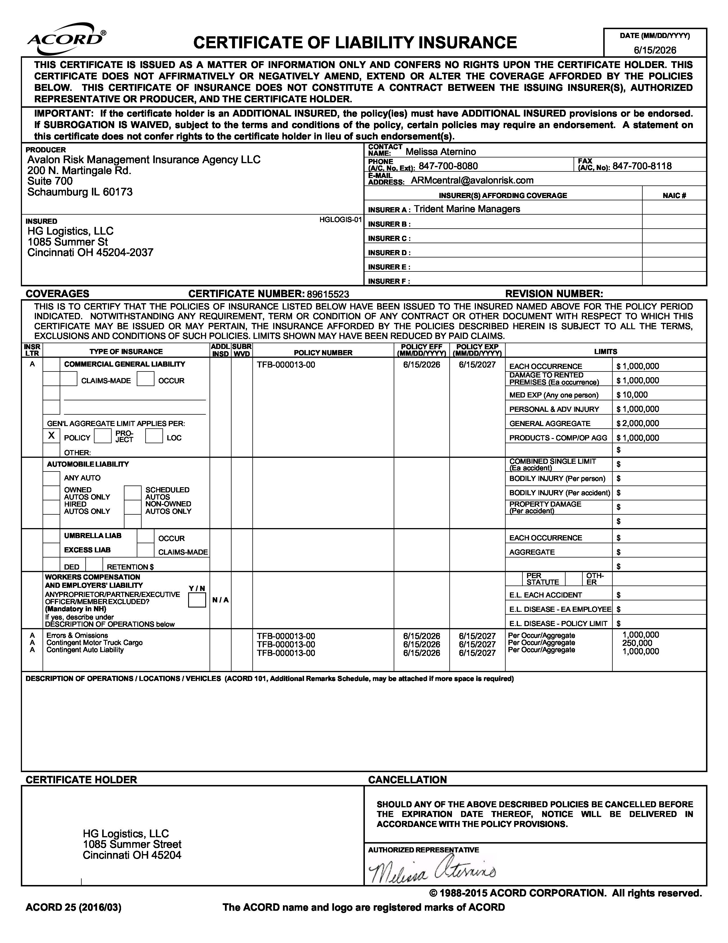
logistics,llc

logistics,llc
W9 Form

Authority

logistics,llc
Payment Method

logistics,llc

HG Logistics LLC accepts payments by ACH, credit card, or check. Please specify
how you will be submitting your payment. Fill out the required information if
paying by credit card. Sign and email completed form to nsauers@hglogisticsllc.com.

- BANK (ACH)

Account Type: Checking

Name on Account: HG Logistics LLC Bank Name: First Merchants Bank

Routing Number: 074900657 Account Number: 101924386

Contact Name: Nancy Sauers Contact Phone #: 513-244-4195

Remittance Email: nsauers@hglogisticsllc.com

3 1/2% Processing Fee Will Be Applied
- CREDIT CARD

Card Type: Visa Mastercard American Express

Name on Account:

Card Number:

Expiration: (mm/yy) CVV: Cardholder Zip Code:

Email Address to Send Receipt:

- CHECK

Mail to 1085 Summer Street, Cincinnati, OH 45204.

CUSTOMER’S SIGNATURE: _____________________________________ DATE: _____________

